**Access Statement for Redwings Oxhill**

**Introduction**

Redwings Oxhill is located near the village of Oxhill on the A422 in a beautiful rural location. It is equidistant between Stratford upon Avon and Banbury.

You can meet dozens of rescued horses and ponies at the centre for free, see our rehoming teams at work and learn about all our other equine residents who live at other Redwings centres across the country.

The centre is on level ground with no steep inclines and is a member of the Visitor Attraction Quality Assurance Scheme. We can provide a wheelchair and wheelchair ramps provide access to all areas.

We look forward to welcoming you to the centre. If you have any queries or require assistance, please phone 01508 505246 or email info@redwings.co.uk

**Pre-Arrival**

* The nearest railway stations are Stratford upon Avon and Banbury which are 10 miles away.
* We have a wheelchair available, disabled access toilet, and ramps to make the whole centre accessible.
* There are always staff on hand to assist all our visitors.

**Car Parking**

* There are around 50 car parking spaces, with an additional six spaces reserved for blue badge parking a few metres from the entrance to the Visitor Centre. All parking is free.
* The car park surface is a mix of concrete and gravel, and there are also grass areas suitable for parking in dry conditions. The car parking areas are flat and level.
* Staff at the reception desk can see approaching visitors and provide assistance.
* The entrance to the visitor centre is a gently sloping non-slip ramp. The main doors are patio style full length double glass doors with wooden ramps and can be opened individually.
* When both doors are open the width is 1440mm.

*Car park*

*Disabled parking spaces Ramp from car park to entrance*

*Entrance doors*

**Main Entrance & Reception**

* The area around the front desk provides ample room for small groups or wheelchair users. The reception desk is directly in front of the Visitor Centre entrance.
* The Visitor Centre is open plan. There is a gift shop and reception area with a café to the rear and the floor is flat and on one level. Lighting is provided as spotlights.
* Seating is available in the café area.
* There is no hearing loop system but plenty of signage showing exits, fire assembly and smoking points, and exits.

**Toilets**

* WC and washroom facilities are in the form of a portacabin style toilet block situated 18metres from the visitor centre entrance. The width of the door to the disabled toilet is 930mm and the height of the WC to the floor is 490mm.
* There is a red alarm cord which will activate and alarm outside the WC.
* There are baby-changing facilities in one of the washrooms.

*Disabled toilet and baby change*

**Catering**

* There is a café in the Visitor Centre providing refreshments and food and on the same level as the gift shop and reception area.
* The café area is compact, but tables can be moved if required to accommodate visitors with access needs.
* There is additional seating on the decking area outside the Visitor Centre which can be accessed by the doors adjacent to the café counter. The decking is of wood construction and has a retractable canopy which can be opened of closed depending on weather.
* The chairs are 450mm high and tables 740mm high with a clear space underneath the tables of 690mm.
* Menus are on each table and staff can readout menus to visitors if required.

**Grounds & Gardens**

* The walkways throughout the site are accessible by wheelchair and the route indicated by directional signage. Guidance and information will be provided by Visitor Centre staff upon arrival.
* The site is, and has, undergone significant refurbishment and access to the far end of the site, including our Memorial Garden, is now possible.
* Access to the rehoming barn and stables is wheelchair friendly with a flat, concrete surface around these buildings with ramps where required.
* There are benches at intervals along the paddock walkways and in the memorial garden.
* There are adequate handwashing facilities on site and several hand sanitisers stations approximately 1100m in height.

*Walkway surfaces*

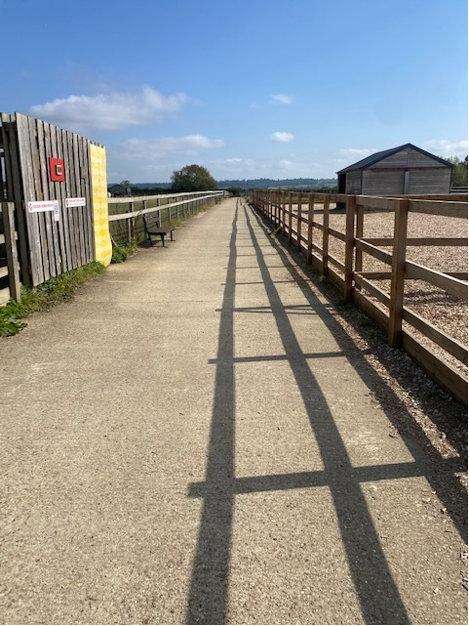

**Additional Information**

* Visitors are made aware of the location of the fire assembly point shortly after their arrival.
* Staff are trained to assist visitors if an emergency arises.
* There is always first aid trained staff on site and there is a defibrillator located onsite.
* All dogs on leads are welcome on site and water bowls and dog waste bins are provided.
* There is a single smoking point on site in the car park area. No smoking is permitted in any other part of the site.