**Access Statement for Redwings Caldecott**

**Introduction**

Redwings Caldecott is located between the villages of Belton and St Olaves, just off the A143 in South Norfolk. It’s approximately 7 miles from Great Yarmouth and 21 miles from Norwich City.

You can meet dozens of rescued horses and ponies at the centre for free, see our rehoming team at work and learn about all our other equine residents who live at other Redwings centres across the country.

The centre is on level ground. Redwings Caldecott is also a member of the Visitor Attraction Quality Assurance Scheme. We can provide a wheelchair to assist to the paddocks.

We look forward to welcoming you to the centre. If you have any queries or require assistance, please phone 01508 505246 or email info@redwings.co.uk

**Pre-Arrival**

* The nearest railway stations are Haddiscoe (3 miles) and Somerleyton, (5 miles).
* We have a wheelchair available. There is an accessible toilet to the rear of the Welcome Centre, Gift shop and Sydney Suite.
* There are always staff on hand to assist our visitors.

**Car Parking**

* There are around 133 car parking spaces at the main Welcome Centre, with 6 spaces reserved for blue badge parking a few metres from the entrance to the Visitor Centre. All parking is free. There is a parking and turning area designated for coaches.
  + The car park surface is a mix of concrete and gravel.
* There are an additional 30 car parking spaces at the Gift Shop & Café
  + There are no reserved spaces for blue badge parking.
  + The car park surface is a mix of compacted hardcore and gravel.
* The main road from the A143 to Redwings and linking the Welcome Centre and café and gift shop is tarmac.
* There are no gates to open/ close whilst driving.
* Staff at the reception desk can see approaching visitors and give assistance.
* The entrance path to the visitor centre is tarmac and gravel.
* There are double, full-length, glazed doors to the Welcome Centre. They can be opened individually.
* When both doors are open the width is 1610mm.

**Main Entrance & Reception**

* The area around the front desk provides ample room for small groups or wheelchair users.
* The reception desk is directly in front of the Welcome Centre entrance.

*The Welcome Centre*

**Café and Gift Shop**

* A single entry door opens outwards and is 1090mm wide.
* The café/ gift shop is open plan.
* There is café seating in the Gift Shop, the attached Sydney Suite and outside.
* The Sydney Suite is accessible across a lobby to the right of the gift shop till. The floor is flat and on one level. Lighting is provided as recessed downlighters.
* There is no hearing loop system but plenty of signage showing exits, fire exits, fire assembly point and smoking point.

*Caldecott Hall housing the Sydney Suite, gift shop and café.*

**Toilets**

* WC and washroom facilities (including accessible toilet) are to the rear of the Welcome Centre, the gift shop and the Sydney suite.
* The width of the door to the accessible toilet is 950 mm and the height of the WC to the floor is 450mm.
* There is a red alarm cord which will activate and alarm outside the WC.
* There are baby-changing facilities in each accessible toilet.

*Accessible toilet*

**Catering**

* The café provides refreshments and food and on the same level as the gift shop.
* Tables can be moved if required to accommodate visitors with access needs.
* The chairs are 460mm high and tables 750mm high with a clear space underneath the tables of 720mm.
* Menus are on most tables in addition to blackboard menu. The menu can be read to visitors if required.
* The gift shop is accessible.
* There is additional seating in the garden outside the gift shop/ café which can be accessed via folding patio doors.

*Oliver’s Café*

**Grounds & Gardens**

* The walkways through most of the site are accessible by wheelchair and the route indicated by directional signage. Approximately half of the pathways are grass. The rest are gravelled tracks.
* Guidance and information will be provided by Visitor Centre staff upon arrival.
* Access to the stables is wheelchair friendly with a flat, concrete surface around these buildings.
* There are benches at intervals along the paddock walkways and in the memorial garden.
* There are adequate handwashing facilities on site and several hand sanitiser stations approximately 1200m in height.

*Examples of path surfaces across the centre*

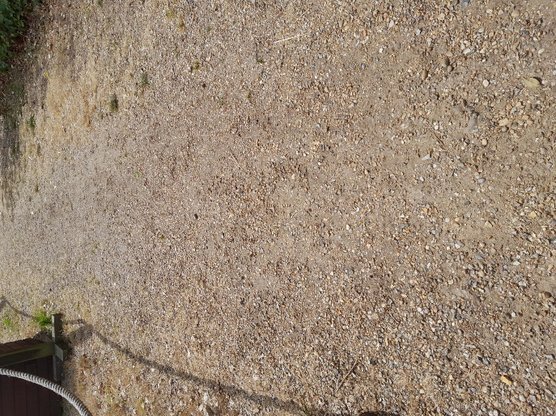

**Additional Information**

* Fire Assembly points are in each car park and signposted by a large green/white Fire Assembly sign.
* Staff are trained to assist visitors if an emergency arises.
* There is always first aid trained staff on site and there is a defibrillator located for staff access near the Welcome Centre.
* All dogs on leads are welcome on site and water bowls and dog waste bins are provided.
* There is a single smoking point on site in both car park areas. No smoking is permitted in any other part of the site.
* Permanent staff are Dementia Friends. [dementiafriends.org.uk](https://www.dementiafriends.org.uk/)
* Electric hand driers are in situ. These can be turned off on request.