Access Statement for Redwings Ada Cole
Introduction
Redwings Ada Cole is situated in Broadley Common, 3.5 miles from the centre of Harlow. The centre is home to more than 80 rescued horses and donkeys. Some are permanent residents at the Sanctuary, whilst others are looking for loving Guardian homes.
Redwings Ada Cole is at ground floor level and has a gift shop and café. The centre is a member of the Visitor Attraction Quality Assurance Scheme. You can meet dozens of rescued horses, ponies and donkeys and learn about all our other equine residents who live at other Redwings centres across the country. We can provide a wheelchair to assist visiting the paddocks.
We look forward to welcoming you. If you have any queries or require any assistance, please phone 01508 505246 or email info@redwings.co.uk.
Pre-Arrival
- For full details of how to reach us, please see the ‘How to Get There’ section of our website. Our postcode is EN9 2DH.
- The nearest railway station is Harlow Town Station, which is approximately 4 miles away. Taxis are available at the station.
Car Parking and Arrival
- The centre is accessed by a short driveway. There is a closed gate at the bottom of the driveway which must be opened manually.
- There is onsite parking for 40 cars behind the Visitor Centre. There are three Blue Badge parking spaces at the front of the Visitor Centre.
- After the gate, turn immediately left for the main car park. Go straight on for Blue Badge spaces.
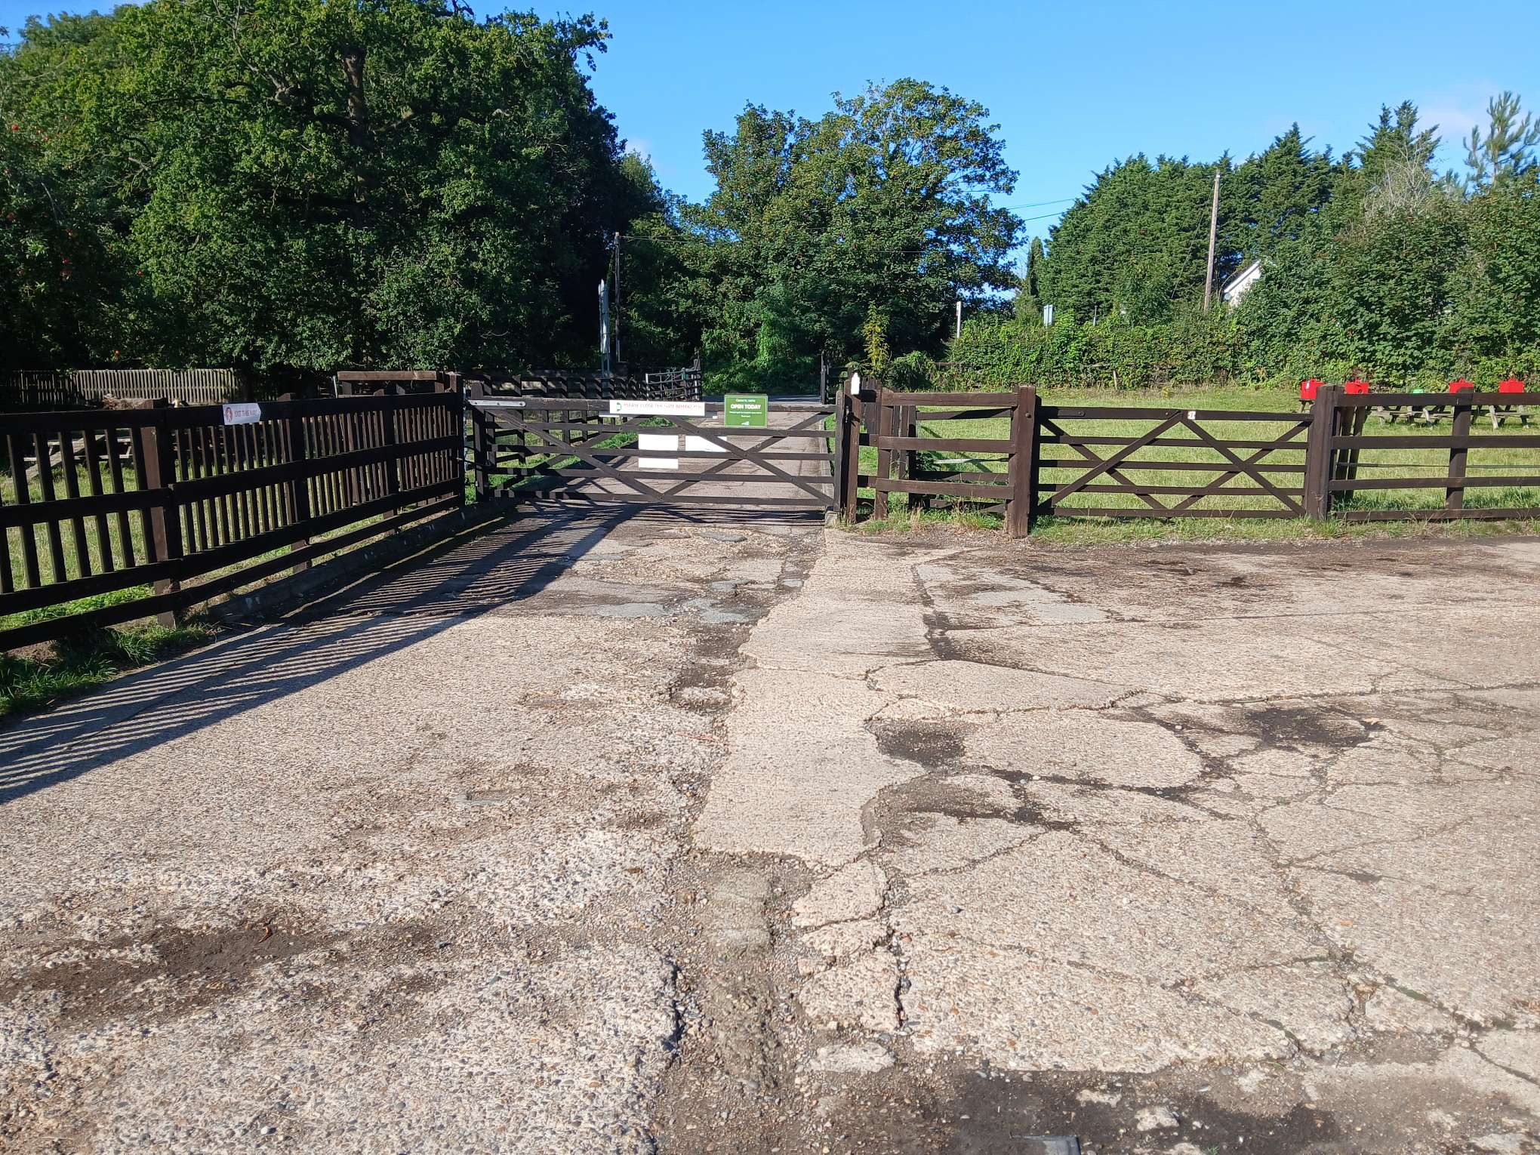
Entrance gate
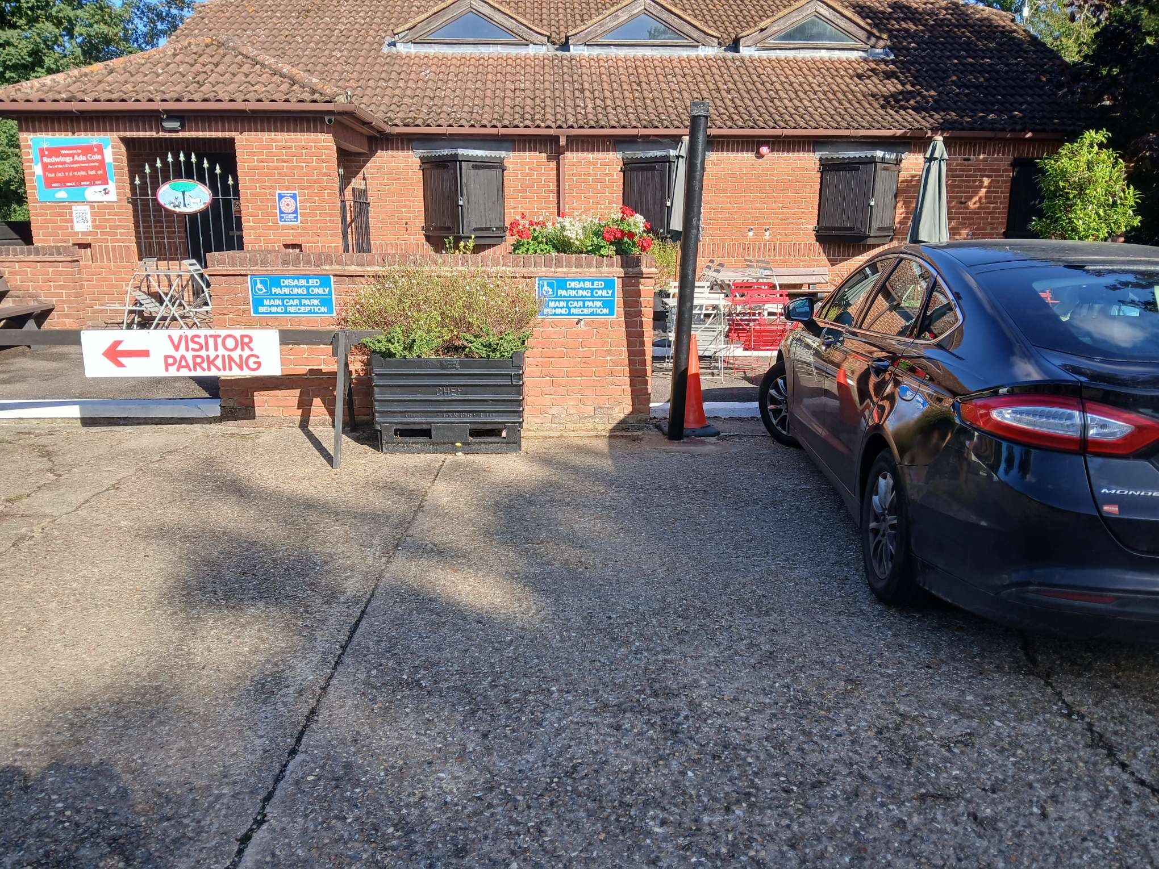
Accessible parking at the front of the Visitor Centre
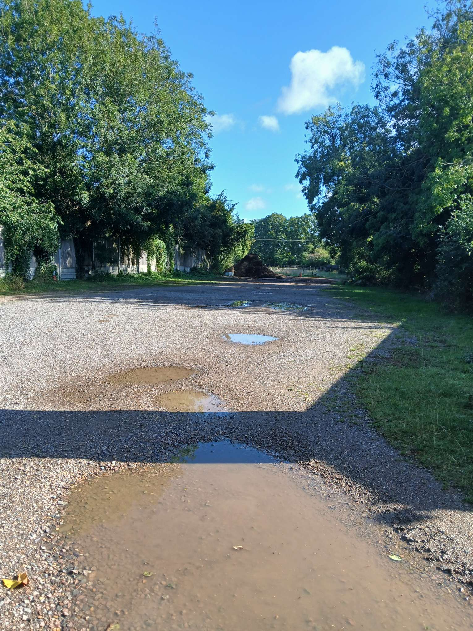
Main car park

Main Entrance, Reception and Ticketing Area
- There are two steps leading up to the reception as well as a permanent concrete ramp.
- The Visitor Centre has manual double doors with a door opening width of 1760mm.
- The reception desk is 910mm high, with a lowered section.
- The floor surface is tiled.

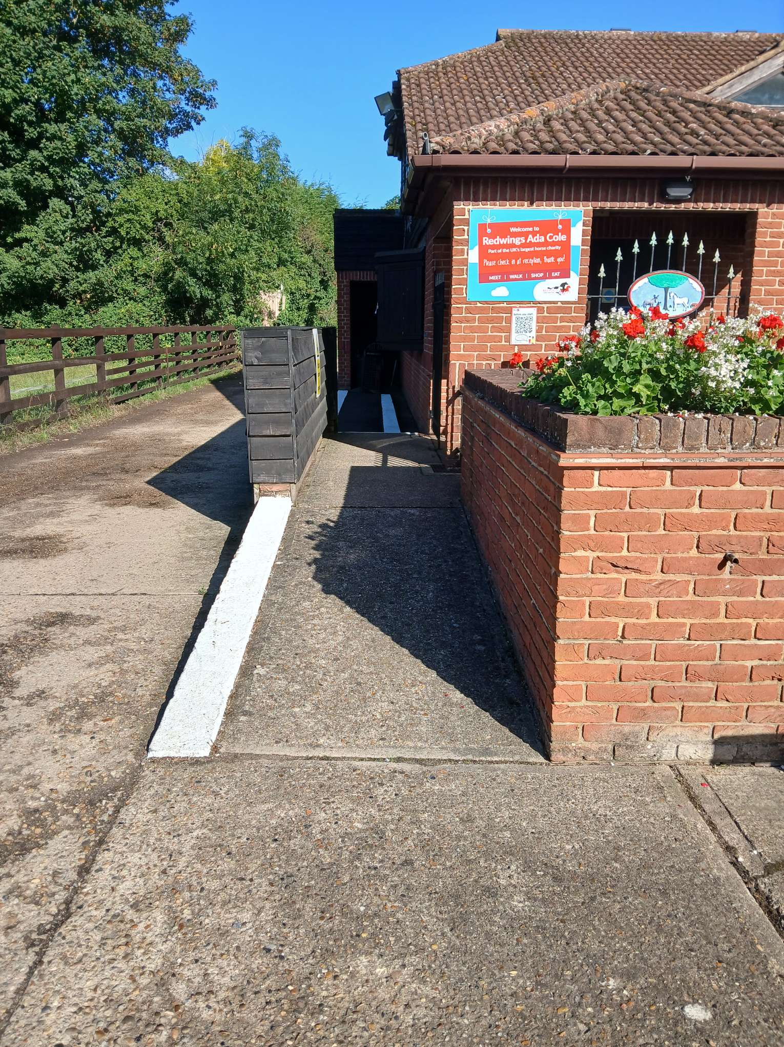
Entrance to reception

Public Toilets
- The main toilets are in the stable yard.
- The unisex accessible toilet is on the ground floor with level access from the café.
- The door is light and easy to open and is 813mm wide.
- The toilet height is 432mm.
- There is a horizontal grab rail on the wall adjacent to the toilet and a drop-down grab rail the other wide. There is a vertical grab rail on the left-hand side of the basin.
- The sink is 724mm and the taps are lever types.
Catering
- There is a small cafe inside the Visitor Centre. It serves light refreshments, including teas and coffees and delicious cakes and snacks.
- The tables in the cafe are 68.6cm high.
- The flooring in the cafe is linoleum.
- A highchair is available.
Shop(s)
- The shop consists of tall display racks, and low tables and baskets accessible from a seated position. Staff are always on hand to help.
- The shop is level throughout.
- The flooring in the shop is red tiled.
Grounds and Gardens
- There are level concrete walkways through the centre. There are also grassy paths which may be uneven.
- There is a small seating area outside on both a concrete and a grassy area.
- There are benches located around the Centre.
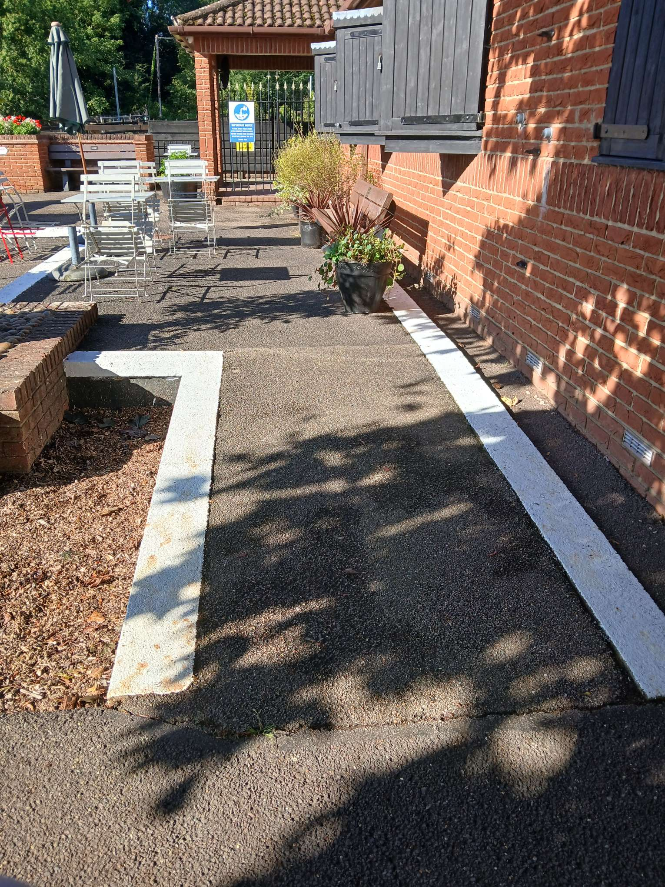
Outside seating area

Additional Information
- All dogs on a lead are welcome on site and water bowls and dog waste bins are provided.
- The Fire Assembly point is on the track at the start of the main walkway and is signposted with a large green/white Fire Assembly sign.
- Staff are trained to assist visitors if an emergency arises.
- There is always first aid trained staff on the site and a defibrillator is located within the Visitor Centre.
- There is a single smoking point on site in the car park area. No smoking is permitted in any other part of the site.

